Buzz Wire Game (Steady Hand Game)

Description:
The Buzz Wire Game is a popular steady-hand challenge where the player guides a metal loop along a twisted wire path without touching it. If the loop touches the wire, a buzzer sounds and an LED light up, indicating failure.
Block Diagram:
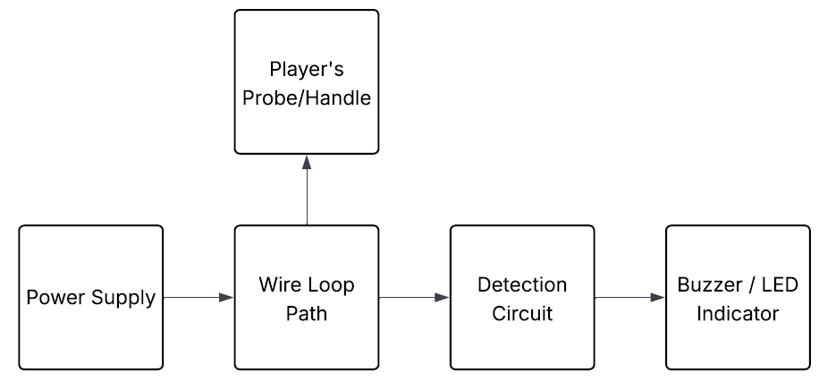
Pinout / Circuit Connection:
• Power Supply (+) → Bent Metal Wire
• Loop Wire → LED (+) and Buzzer (+)
• LED (–) → GND (via resistor if required)
• Buzzer (–) → GND
• Power Supply (–) → GND

Components Required:
- Metal wire shaped as path
- Buzzer
- LED
- Power supply
- Jumper wires
Working Principle:
The bent wire and loop act as electrical contacts. When the loop touches the wire, the circuit closes. Arduino (or direct connection) detects this event and triggers the buzzer and LED. If no contact is made, the circuit remains open and the player continues. This simple principle of circuit closure forms the basis of many interactive games.
Operation (Step-by-Step):
• Arrange the bent wire in a desired shape
• Connect the circuit as per the diagram
• Power ON the system
• Move the loop along the wire carefully
• If the loop touches the wire → LED glows and buzzer sounds
• If the loop does not touch the wire → no output
• The game continues until the end of the wire track
Conclusion:
The Buzz Wire Game demonstrates practical application of electrical contact detection and provides an enjoyable way to test hand–eye coordination. It’s an engaging project for beginners to understand open and closed circuits, while making electronics interactive and fun.
References:
[1] Arduino Project Hub, “Steady Hand Game,” Arduino.cc, 2019. [Online]. Available: https://projecthub.arduino.cc. [Accessed: Sep. 13, 2025].
[2] C. Platt, “Make: Electronics,” 2nd ed., Maker Media, 2015.

